When every risk is material: disclosed risk convergence, documented response and organisational resilience in US firms, 2017 to 2025
Imo J. Enang
Structured abstract
Purpose. This study examines whether the convergence of emerging strategic risks in corporate disclosure identifies which firms lose most when systemic shocks arrive and whether documented responses to those risks protect performance.
Design/methodology/approach. A stratified random sample of 787 US non-financial firms supplied 6,214 annual reports for fiscal years 2017 to 2025. Dictionary measures of nine risk categories in Item 1A were validated against macro-uncertainty indices and a sentence audit and then linked to SEC financial data and to geopolitical, policy-uncertainty and supply-chain pressure indices. Pre-registered cross-sectional models examine the pandemic and 2022 shocks; firm fixed-effects panels test exposure-by-shock interactions.
Findings. Mean convergence breadth rose from 5.06 to 7.83 material categories while dispersion across firms halved. Breadth did not predict the pandemic revenue fall but predicted stronger recovery among firms reporting no documented action. Documented responses were rare and mostly routine hedging; they did not reduce losses. Losses followed specific channels: macro-financial exposure lowered growth and margins in high policy-uncertainty years, with no compounding from combined exposure.
Research limitations/implications. Measures rest on disclosure text and nominal accounting outcomes; human double-coding of the dictionary remains outstanding.
Practical implications. Boards should treat the risk-factor list as a compliance record and test exposure by transmission channel with operational evidence.
Originality/value. The study gives large-sample evidence that disclosed risk convergence has become near-universal and uninformative about shock losses, separating disclosure from documented action.
Keywords. Strategic risk, Risk convergence, Risk disclosure, Organisational resilience, Dynamic capabilities, Strategic foresight, Enterprise risk management, Polycrisis
Paper type. Research paper

Introduction
Boards now read annual reports in which almost every risk is listed as material. In fiscal 2017 the typical sampled US firm discussed 5.06 of nine emerging risk categories at length in its risk factors; by fiscal 2025 the figure was 7.83 with 35.3 per cent of firms covering all nine. The period behind this change brought a pandemic and three extreme index readings: the highest global supply-chain pressure since the index begins in 1998 (December 2021), the highest geopolitical risk since March 2003 (March 2022) and the highest US trade policy uncertainty since 1985 (April 2025) (Benigno et al., 2022; Caldara and Iacoviello, 2022; Baker et al., 2016). Scholars of systemic risk describe such periods as a polycrisis in which crises in different systems entangle and intensify each other (Lawrence et al., 2024; Helbing, 2013; Renn et al., 2019). Senior executives face the practical version of that claim when they decide how many risks deserve attention and what to do about each (Day and Dennis, 2022; Sheehan, 2020; Soleimani and Stauffer, 2026).
Two assumptions sit behind current practice. The first holds that firms exposed to several emerging risks at once are more fragile, because shocks that arrive together exhaust attention and slack (Ocasio, 1997; Bourgeois, 1981; Lawrence et al., 2024). The second holds that disclosure of a risk signals some capacity to manage it, so that a long and current risk register indicates preparedness (Nocco and Stulz, 2006; Hoyt and Liebenberg, 2011). Neither has been tested at scale. Research that measures risk from corporate text usually builds one category at a time, whether political risk (Hassan et al., 2019), epidemic exposure (Hassan et al., 2023), climate exposure (Sautner et al., 2023) or cyber risk (Florackis et al., 2022). Research on organisational resilience in turn rarely separates what firms disclose from what they report doing (Williams et al., 2017; Linnenluecke, 2017; Hillmann and Guenther, 2021). The closest study shows that pre-crisis disclosure of slack, learning and innovation capabilities in 10-K filings was associated with investor recognition of resilience during the pandemic (Neunsinger et al., 2026). It does not ask whether the number and combination of disclosed risks matter or whether documented action on those risks protects operating performance.
This study addresses three questions. How far do emerging risks co-occur in corporate disclosure and how has that changed since 2017? Does pre-shock convergence of disclosed risk predict performance loss and recovery in systemic shocks beyond the separate effect of each category? Do firms whose documented actions cover the risks they disclose fare better? The evidence comes from 6,214 annual reports filed by a stratified random sample of 787 US non-financial firms, linked to SEC financial statement data and to four public uncertainty indices. Hypotheses, measures and decision rules were committed to the project repository before outcomes were merged with text measures and every deviation is reported. The findings challenge both assumptions. Disclosed convergence became near-universal and lost its power to separate firms; it did not predict who fell furthest in the pandemic; documented responses were rare and mostly routine; and losses followed specific transmission channels without measurable compounding. The paper contributes to strategic risk management and dynamic capabilities research by distinguishing disclosed exposure, documented action and realised sensitivity. It also gives boards a practical diagnostic for each.

Risk convergence, sensing and response
Strategic management has long treated environmental uncertainty as a set of separable conditions to be judged one at a time, each with its own likely effect and response (Rindova and Courtney, 2020; Bundy et al., 2017; Weick et al., 2005). Enterprise risk management inherited that separability. Its frameworks ask firms to list risks, score each on likelihood and impact and aggregate the scores into a portfolio view (Nocco and Stulz, 2006; Bromiley et al., 2015; Andersen, 2008). The empirical literature that measures exposure from corporate text has mostly kept one measure per category (Hassan et al., 2019; Sautner et al., 2023; Florackis et al., 2022), although topic models and large dictionaries can recover many risk types from the same filing (Bao and Datta, 2014; Davis et al., 2020; Dyer et al., 2017). Systemic-risk scholars argue that separability misses the defining feature of the current period, in which shocks interact through shared infrastructure, supply networks and policy responses (Helbing, 2013; Renn et al., 2019; Lawrence et al., 2024). Climate science uses the term compound events for hazards whose joint impact exceeds the sum of their parts (Zscheischler et al., 2018). Supply-network studies show the same pattern in firms, where disruption travels through linked suppliers and losses exceed the direct shock (Carvalho et al., 2021; Elliott et al., 2022; Hendricks and Singhal, 2005; Baldwin and Freeman, 2022).
Dynamic capabilities theory explains why firms facing the same shocks perform differently. Firms sense threats and opportunities, seize them through investment and reconfigure assets as conditions change (Teece et al., 1997; Teece, 2007; Eisenhardt and Martin, 2000). Later work ties these capacities to managerial cognition and to agility under deep uncertainty (Helfat and Peteraf, 2015; Teece et al., 2016; Schilke et al., 2018; Doz and Kosonen, 2010). Strategic foresight specifies the sensing step. Ansoff (1975) argued that firms can act on weak signals before threats take full form. Longitudinal evidence links mature foresight practice to later profitability and market value (Rohrbeck and Kum, 2018; Vecchiato, 2012; Rohrbeck et al., 2015). The attention-based view adds that what executives notice and write about shapes what the organisation does. Studies of incumbents facing technical change show that attention expressed in corporate text precedes strategic action (Ocasio, 1997; Eggers and Kaplan, 2009; Nadkarni and Barr, 2008; Cho and Hambrick, 2006). Organisational ambidexterity explains how firms protect current operations while exploring new positions (March, 1991; O'Reilly and Tushman, 2013; Raisch and Birkinshaw, 2008), which matters when several threats demand simultaneous defence of the core and renewal. In this study dynamic capabilities supply the main mechanism and foresight specifies how sensing works when signals are many and linked. Ambidexterity is retained as an explanation for why some responses are affordable; the data contain no reliable measure of it, so it is not tested.
Convergence should make each capability harder to exercise. When several categories of risk are material at once, executive attention is divided across more domains (Ocasio, 1997; Cho and Hambrick, 2006) and responses compete for the same slack (Bourgeois, 1981). Protection against one threat can raise exposure to another, as when a firm concentrates sourcing to cut cost and so becomes more exposed to trade and geopolitical disruption (Baldwin and Freeman, 2022; Ivanov and Dolgui, 2020). Resilience research describes the capacity to absorb shocks and recover and shows that slack, prior practices and financial flexibility shape both the depth of the fall and the speed of recovery (Ortiz-de-Mandojana and Bansal, 2016; DesJardine et al., 2019; Fahlenbrach et al., 2021; Ding et al., 2021; Duchek, 2020). A firm with broad exposure is more likely to meet a systemic shock on several fronts at once with less room to move resources between them. Contributions to this journal on scenario practice, threats across partner networks and agility make the same practical point (Schoemaker, 2022; Mortlock and Osiyevskyy, 2023; Dencik et al., 2023; Schoemaker and Truumees, 2026).
H1. In a systemic shock, firms with greater pre-shock convergence of emerging risk exposures experience greater performance loss after accounting for the intensity of each risk category.
Risk disclosure is an imperfect record of risk management. Since December 2005 US registrants have had to describe their most significant risks in the annual report (Securities and Exchange Commission, 2005). Accounting research shows that these disclosures carry information about firm risk that investors use (Campbell et al., 2014; Kravet and Muslu, 2013; Hope et al., 2016). The same research documents rising length, repetition and boilerplate (Dyer et al., 2017; Cohen et al., 2020; Brown and Tucker, 2011; Lang and Stice-Lawrence, 2015), so a risk named in the risk factors may describe the hazard without any change in what the firm does. Institutional theory calls the gap between formal statements and practice decoupling (Meyer and Rowan, 1977; Westphal and Zajac, 2001; Bromley and Powell, 2012). Power (2009) argued that risk management often produces documentation that reassures rather than prepares. Selective disclosure is well documented in environmental reporting (Marquis et al., 2016). Two firms that disclose the same supply-chain exposure can differ in what they have done about it. The dynamic capabilities view predicts that the firm which has acted will absorb a shock better (Teece, 2007; Wenzel et al., 2021).
The study therefore separates the risks a firm discloses from the actions it reports having taken on them. Response coverage is the share of a firm's material risk categories for which its business description or management discussion reports a completed action. Coverage is still disclosure. It records actions on hazards, so its match with the risk profile indicates whether sensing has turned into seizing and reconfiguring (Teece, 2007; Day and Schoemaker, 2016; Schoemaker and Day, 2021). Figure 1 summarises the model.
H2. In a systemic shock, firms with greater pre-shock response coverage experience smaller performance loss and stronger recovery.
H3. Response coverage weakens the association between pre-shock risk convergence and performance loss.
Figure 1. Research model
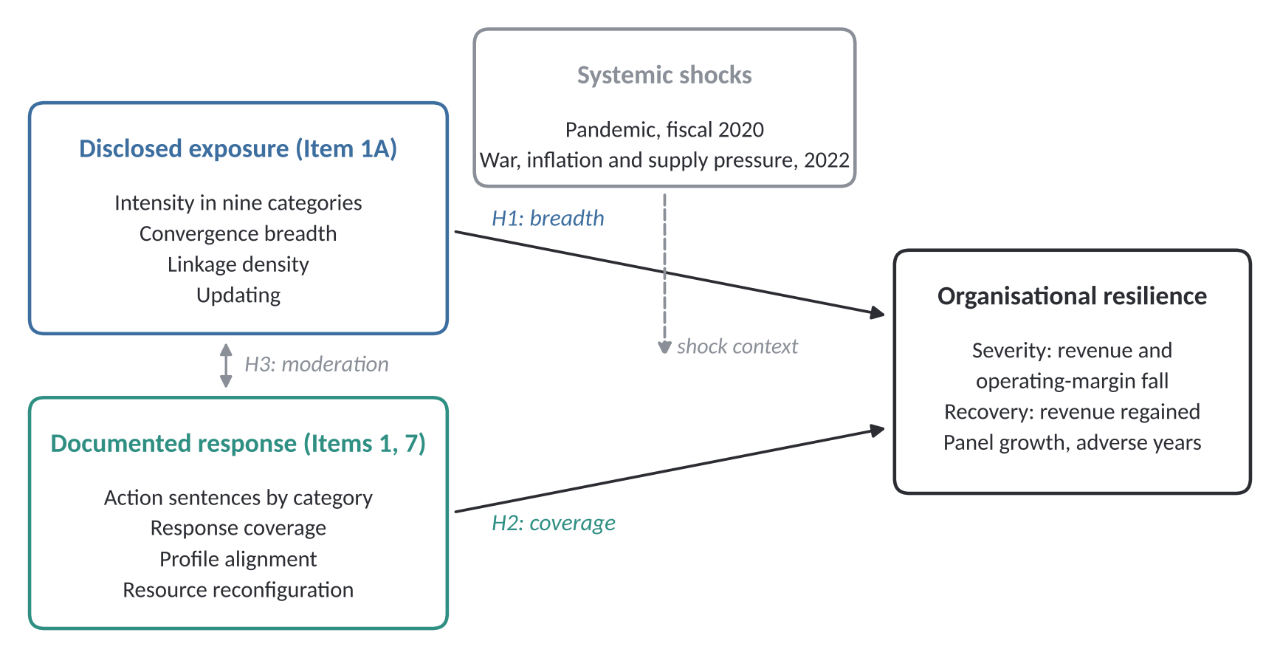
Source: author's design.

Data and method
The sampling frame started from the 5,720 entities that reported a 2018 public float in SEC XBRL data. Of these, 2,277 reported a float of at least 0.5 billion US dollars. Excluding finance and real estate together with utilities and unclassified entities and requiring a 10-K for fiscal 2018 left 1,597 eligible firms. A proportional stratified random sample of 800 was drawn by SIC division with a fixed seed. Before estimation 13 sampled firms were removed because their reported public float was implausible for their size, because they report in Canadian dollars or because they are blank-check companies, leaving 787 firms. Firms were not required to survive to 2025, so the panel is unbalanced and includes firms that were acquired or delisted. Table 1 lists the data sources and Table 2 the sample characteristics.
Table 1. Data sources, content and coverage
Source | Content used | Coverage | Role in the study
SEC EDGAR submissions and 10-K filings | Items 1, 1A and 7 of the latest original 10-K for each fiscal year | 787 firms; 6,214 filings; fiscal 2017 to 2025 | Risk exposure, convergence, documented response, updating
SEC XBRL company facts | 2,240,714 fact rows from 10-K and 10-Q filings; first-reported annual values | Fiscal 2013 to 2026 | Revenue, operating margin, controls, resource commitments
SEC XBRL frames (public float) | Entity public float reported for 2018 | 5,720 entities | Sampling frame
Geopolitical Risk index (Caldara and Iacoviello) | Monthly global index with threats and acts components | 1985 to September 2026 | Geopolitical shock; tracking validity
Economic Policy Uncertainty (Baker, Bloom and Davis) | US news-based index; trade policy and regulation components | 1985 to September 2026 | Policy and trade shocks; tracking validity
Global Supply Chain Pressure Index (Federal Reserve Bank of New York) | Monthly standardised index | 1998 to September 2026 | Supply-chain shock; tracking validity
World Uncertainty Index (Ahir, Bloom and Furceri) | Quarterly global and US indices | 1952 to 2026 third quarter | Supplementary uncertainty measure
Note: Macro indices were averaged over the twelve months ending in each firm's fiscal year-end month. Retrieval dates, file checksums and collection code are held in the project repository. Source: author's compilation.
All filings were retrieved from the SEC EDGAR submissions interface under its fair-access rules with a declared user agent, request throttling and caching, through scripts run in the project's continuous-integration workflow. For each firm and fiscal year from 2017 to 2025 the latest original 10-K was converted to text after removing numeric tables. Items 1, 1A and 7 were then located by heading patterns anchored to line starts. Item 1A was extracted from 99.8 per cent and the management discussion from 98.4 per cent of the 6,214 filings; annual-report exhibits were used where the discussion was incorporated by reference. Fiscal years follow the Compustat convention. Financial data come from 2,240,714 XBRL fact rows. Annual values are those first reported for each period, so later restatements cannot leak information that was not available at the time. Revenue is the largest revenue concept reported for the year, because some filers tag only part of revenue with the contract-revenue concept. The Geopolitical Risk index, the US economic and trade policy uncertainty indices, the World Uncertainty Index and the Global Supply Chain Pressure Index were downloaded from their publishers and averaged over the twelve months ending in each firm's fiscal year-end month (Caldara and Iacoviello, 2022; Baker et al., 2016; Ahir et al., 2022; Benigno et al., 2022). Raw files, checksums, retrieval dates and code are held in the project repository.
Each Item 1A sentence was assigned to any of nine categories using a dictionary of phrase patterns. The categories are geopolitical conflict, trade policy, regulatory change, cybersecurity, artificial intelligence and technology, supply chain, climate and environment, macro-financial instability and pandemic. A transparent dictionary was preferred to a trained classifier because its errors can be inspected sentence by sentence (Loughran and McDonald, 2011; Loughran and McDonald, 2016; Gentzkow et al., 2019). A category is material for a firm-year when it accounts for at least three sentences. Convergence breadth counts material categories from zero to nine. Linkage density is the share of sentences naming two or three categories; sentences naming four or more are hazard catalogues and are excluded from linkage. Documented response sentences in Items 1 and 7 have an organisational subject, a realised action verb within twelve words of a category term and no conditional modal, negation or accounting-treatment language. Response coverage is the share of material categories with at least one such sentence. Disclosure updating is one minus the cosine similarity of the content-word vector of Item 1A with the previous year's (Cohen et al., 2020; Brown and Tucker, 2011).
Three validity checks used no human coding. The categories behaved as expected across industries: supply-chain language was most frequent in wholesale trade (3.77 per cent of sentences in fiscal 2018) and least frequent in services (0.66 per cent), while climate language was highest in mining and construction. Geopolitical, trade and macro-financial intensity rose with the foreign share of pre-tax income (Spearman correlations of 0.19, 0.23 and 0.25, n = 518, all p < 0.001). Across fiscal years, mean geopolitical intensity tracked the Geopolitical Risk index (r = 0.86), trade intensity tracked trade policy uncertainty (r = 0.83) and regulatory intensity tracked regulatory policy uncertainty (r = 0.76); supply-chain intensity did not fall back when supply pressure eased (r = 0.19). An audit of a stratified sample of classified sentences then found low precision for some patterns, notably 'sanctions', which matched legal penalties as well as economic sanctions (25 of 40 geopolitical sentences correct). The dictionary was revised once and audited again on a fresh sample drawn with a different seed, where pooled category precision rose from 0.86 to 0.94. Precision remained lower for supply chain (14 of 20) and for documented responses (36 of 60). Of 40 unclassified sentences 6 contained category content. The audit was carried out with an AI assistant and is reported as such; human double-coding of the released validation samples is the main outstanding measurement task. Results with the original dictionary are reported as a robustness check.
The hypotheses were tested in two shock episodes. In the pandemic episode, severity is the log change in revenue from fiscal 2019 to fiscal 2020, margin change is the change in operating margin over the same years and recovery is the log ratio of fiscal 2022 to fiscal 2019 revenue. Predictors come from the fiscal 2018 10-K, filed before the pandemic by every firm. The 2022 episode combined war with inflation, interest-rate rises and supply pressure. Its outcomes compare fiscal 2022 and 2023 with fiscal 2021 and predictors come from the fiscal 2020 10-K. The models are ordinary least squares with two-digit SIC and fiscal year-end month fixed effects. They control for the nine category intensities and for log assets, leverage, cash to assets, return on assets, prior two-year revenue growth and log Item 1A length. Errors are clustered by two-digit SIC, with heteroskedasticity-consistent errors as a check (Petersen, 2009; Cameron et al., 2011). Continuous variables are winsorised at the 1st and 99th percentiles and convergence and coverage are standardised. A firm-year panel for fiscal 2019 to 2025 adds firm and year fixed effects with lagged predictors. Because macro indices are common to all firms in a year, their direct effects are absorbed by year effects; they enter only as interactions with each firm's fiscal 2018 exposure, a design in the spirit of exposure-by-shift research (Goldsmith-Pinkham et al., 2020; Borusyak et al., 2022). None of these models identifies causal effects of disclosure. They test whether disclosed convergence and documented response carry information about subsequent performance.

Results
Disclosure converged quickly. Mean breadth rose from 5.06 material categories in fiscal 2017 to 7.83 in fiscal 2025 (Figure 2 and Figure 3). The rise is not a change in sample composition, because the 565 firms present in every year show the same path (5.07 to 7.83). The share of firms with eight or nine material categories grew from 4.1 per cent to 69.8 per cent, while the coefficient of variation of breadth fell from 0.315 to 0.162. Firms became more alike in what they disclose as they disclosed more. Linked sentences that connect two or three categories (geopolitical conflict disrupting supply is a typical example) rose from 1.09 per cent to 3.13 per cent of Item 1A sentences, so explicit reasoning about interaction remains a small part of the text. Median Item 1A length rose from 9,297 to 11,169 words.
Figure 2. Share of firms with each emerging risk category material in Item 1A, fiscal 2017 to 2025
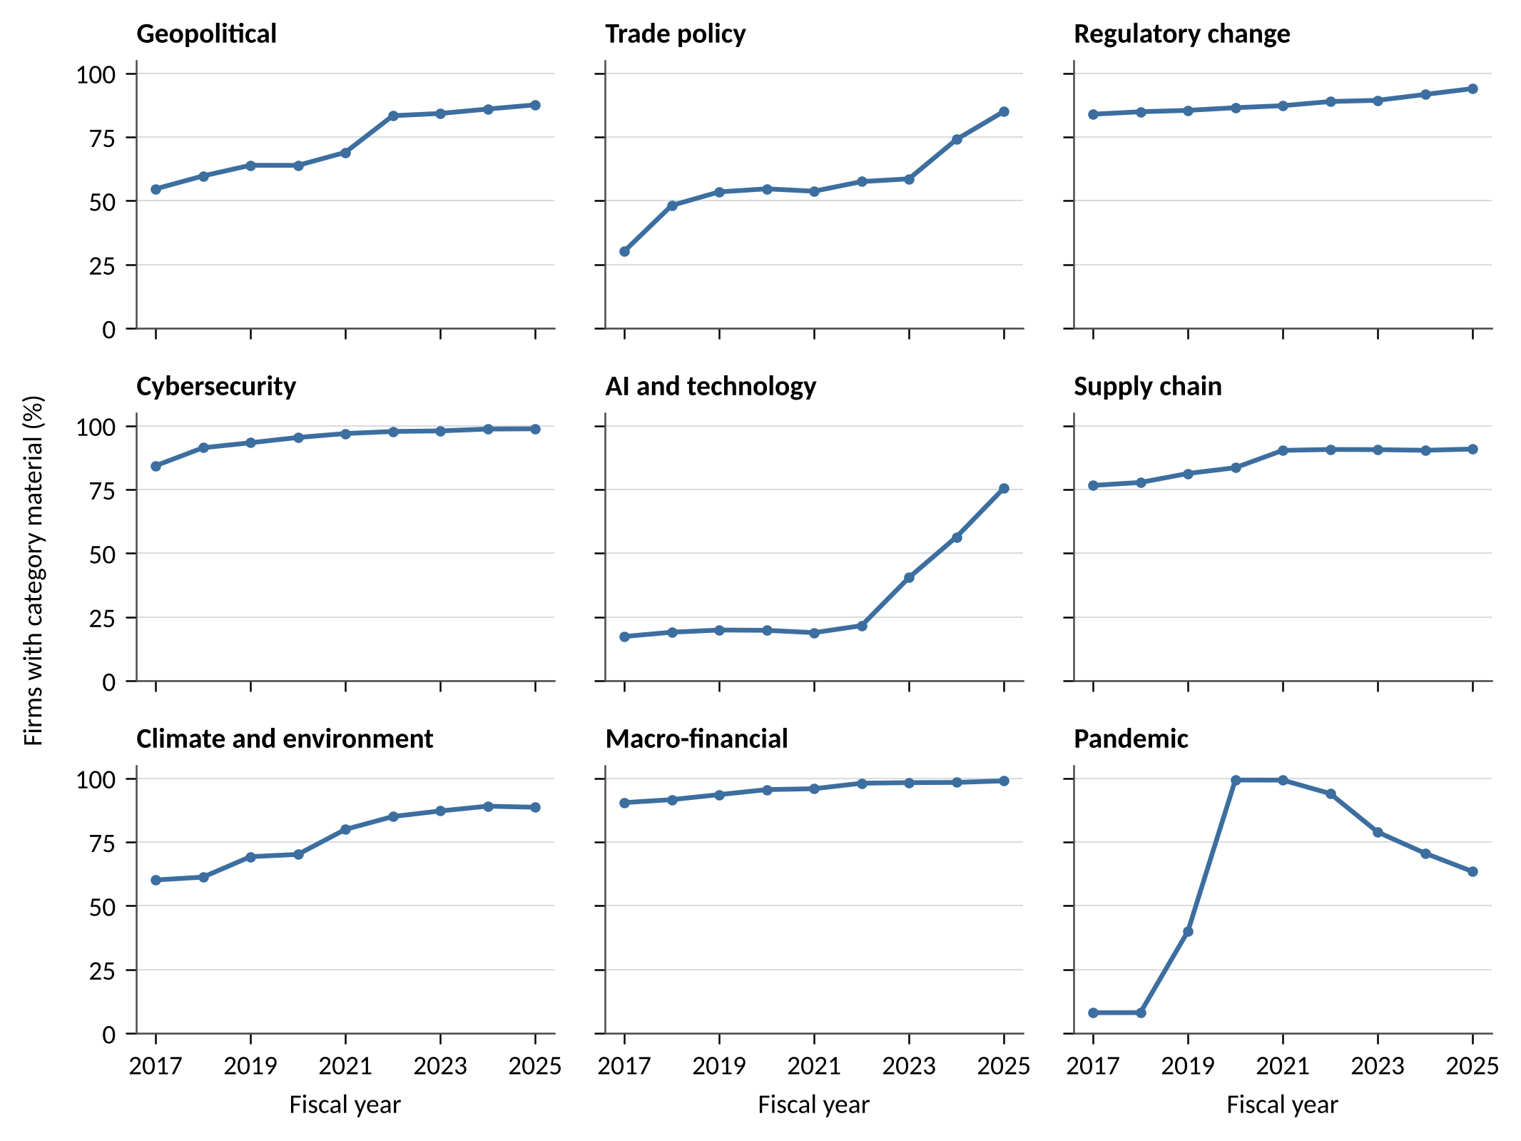
Note: Material means at least three Item 1A sentences in the category. Source: SEC EDGAR 10-K filings of 787 sampled US non-financial firms; author's analysis.
Figure 3. Convergence breadth, dispersion across firms and linked risk sentences, fiscal 2017 to 2025
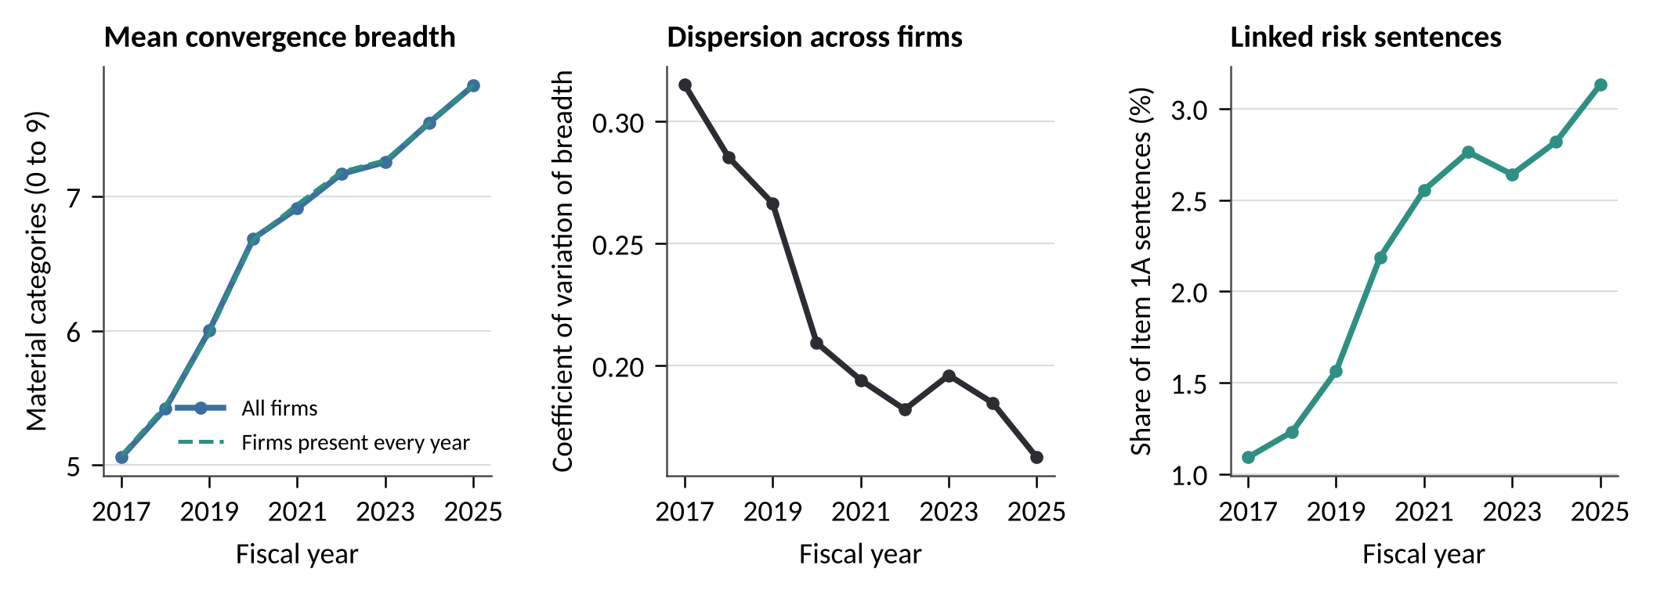
Note: Firms present every year: n = 565. Source: SEC EDGAR 10-K filings; author's analysis.
The category paths show what drove convergence (Figure 2). Material trade-policy disclosure rose from 30.2 per cent of firms in fiscal 2017 to 85.0 per cent in fiscal 2025, geopolitical disclosure from 54.6 per cent to 87.6 per cent and climate from 60.1 per cent to 88.6 per cent. Artificial intelligence and technological disruption stayed near one firm in five until fiscal 2022 (21.6 per cent) and then reached 75.5 per cent in fiscal 2025. Pandemic disclosure went from 8.1 per cent to 99.3 per cent in fiscal 2020 and still stood at 63.4 per cent in fiscal 2025, five years after the shock. Cybersecurity, macro-financial and regulatory risks were already near saturation in 2017. The pattern is a ratchet: disclosure rises with a shock and rarely falls back. Convergence rose in every industry division (Figure 4).
Figure 4. Mean convergence breadth by SIC division, fiscal 2017 to 2025
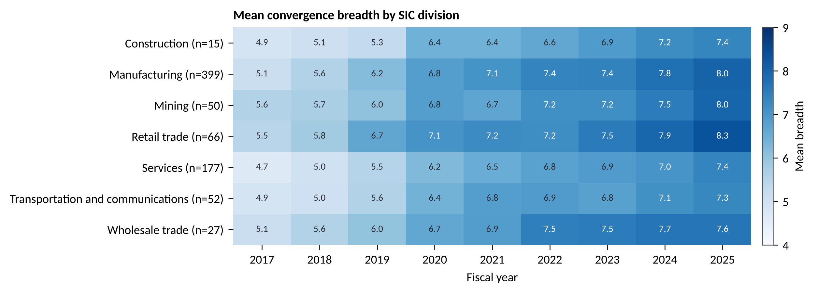
Note: Divisions with at least 15 sampled firms; n = firms in fiscal 2018. Source: SEC EDGAR 10-K filings; author's analysis.
Documented responses were uncommon. In fiscal 2018, 71.0 per cent of firms reported no completed action in any of their material categories. The actions that were reported concentrated in interest-rate and currency hedging (118 firms) and supply arrangements (106 firms). Only 10 firms reported a cybersecurity action and none a trade-policy action, although 48.2 per cent disclosed material trade risk in that year. Mean coverage doubled in fiscal 2020 (13.8 per cent against 6.2 per cent) as firms described pandemic measures, then returned to 8.1 per cent by fiscal 2025. Table 2 reports descriptive statistics for the pandemic episode sample.
Table 2. Sample selection and descriptive statistics for the pandemic episode
Step or variable | Mean [SD] | Firms or n | Median
Panel A. Sample selection
Entities with 2018 public float in SEC XBRL frames |  | 5,720
Public float of at least 0.5 billion US dollars |  | 2,277
Operating company |  | 2,276
SIC code present |  | 2,276
Excluding finance, insurance and real estate (SIC 6000-6999) |  | 1,703
Excluding utilities (SIC 4900-4999) |  | 1,600
Excluding public administration and unclassified (SIC 9000 and above) |  | 1,600
Filed a 10-K for fiscal year 2018 |  | 1,597
Proportional stratified random sample by SIC division (seed 20181231) |  | 800
Validation screen: implausible public float tags, non-US-dollar reporters and blank-check companies (see Frame Validation Exclusions.csv) |  | 787
Panel B. Pandemic episode variables
Revenue severity, ln(FY2020/FY2019) | −0.040 [0.325] | 703 | 0.001
Operating-margin change, FY2020 minus FY2019 | −0.001 [0.816] | 662 | −0.005
Revenue recovery, ln(FY2022/FY2019) | 0.266 [0.378] | 652 | 0.225
Revenue regained by FY2021 (share) | 0.729 [0.445] | 669 | 1.000
Convergence breadth, FY2018 (0 to 9) | 5.419 [1.546] | 787 | 6.000
Response coverage, FY2018 (share) | 0.061 [0.108] | 784 | 0.000
Linkage density, FY2018 (share of sentences) | 0.012 [0.010] | 784 | 0.010
Disclosure updating, FY2018 | 0.024 [0.039] | 760 | 0.014
Note: Outcomes winsorised at the 1st and 99th percentiles. Breadth counts categories with at least three Item 1A sentences. Source: SEC EDGAR filings and XBRL company facts; author's analysis.
Table 3 and Figure 5 report the hypothesis tests. In the pandemic, 44.6 per cent of firms saw revenue fall between fiscal 2019 and 2020 and 27.1 per cent saw a fall of more than ten per cent. Breadth was unrelated to the size of the fall (b = −0.004 per standard deviation, p = 0.765, n = 678) and to the change in operating margin (b = −0.008, p = 0.710). In the 2022 episode breadth was unrelated to the margin change to fiscal 2022 (b = −0.011, p = 0.268) and to revenue change to fiscal 2023 (b = 0.017, p = 0.454). Breadth was associated with a larger margin fall to fiscal 2023 with clustered errors (b = −0.095, p = 0.040) but the association lost significance with heteroskedasticity-consistent errors (p = 0.326) and among firms with base-year revenue of at least 100 million US dollars (b = 0.027, p = 0.431), which places it in a handful of small-revenue firms with extreme margin changes. H1 is not supported. Response coverage was unrelated to severity in either episode (pandemic b = 0.007, p = 0.493; 2022 margin b = 0.001, p = 0.932), so H2 is not supported.
Table 3. Convergence, response coverage and performance in two shock episodes
Term | Pandemic revenue fall | Pandemic margin change | Pandemic recovery | 2022 margin, FY2022 | 2022 margin, FY2023 | 2022 revenue, FY2023
Model H1
Convergence breadth | −0.004 [0.014] | −0.008 [0.022] | 0.056** [0.020] | −0.011 [0.010] | −0.095* [0.046] | 0.017 [0.022]
Observations | 678 | 638 | 627 | 598 | 576 | 611
R squared | 0.464 | 0.309 | 0.272 | 0.214 | 0.218 | 0.265
Model H2
Response coverage | 0.007 [0.010] | 0.004 [0.019] | 0.008 [0.011] | 0.001 [0.008] | 0.013 [0.020] | 0.009 [0.012]
Observations | 678 | 638 | 627 | 598 | 576 | 611
R squared | 0.465 | 0.309 | 0.265 | 0.214 | 0.215 | 0.265
Model H3
Convergence breadth | −0.008 [0.014] | −0.012 [0.024] | 0.051** [0.020] | −0.011 [0.011] | −0.094* [0.047] | 0.018 [0.024]
Response coverage | −0.001 [0.011] | −0.004 [0.019] | −0.003 [0.012] | 0.001 [0.007] | 0.010 [0.022] | 0.010 [0.015]
Breadth x coverage | −0.022** [0.008] | −0.022 [0.013] | −0.035** [0.010] | 0.001 [0.008] | 0.003 [0.015] | 0.000 [0.009]
Observations | 678 | 638 | 627 | 598 | 576 | 611
R squared | 0.469 | 0.310 | 0.279 | 0.214 | 0.218 | 0.266
Note: Coefficients per standard deviation of the predictor with standard errors clustered by two-digit SIC in brackets; * p < 0.05, ** p < 0.01. All models include the nine category intensities, log assets, leverage, cash to assets, return on assets, prior two-year revenue growth, log Item 1A words and two-digit SIC and fiscal year-end month fixed effects. Predictors from fiscal 2018 (pandemic) and fiscal 2020 (2022 episode). Source: author's analysis.
Figure 5. Hypothesis tests with 95 per cent confidence intervals
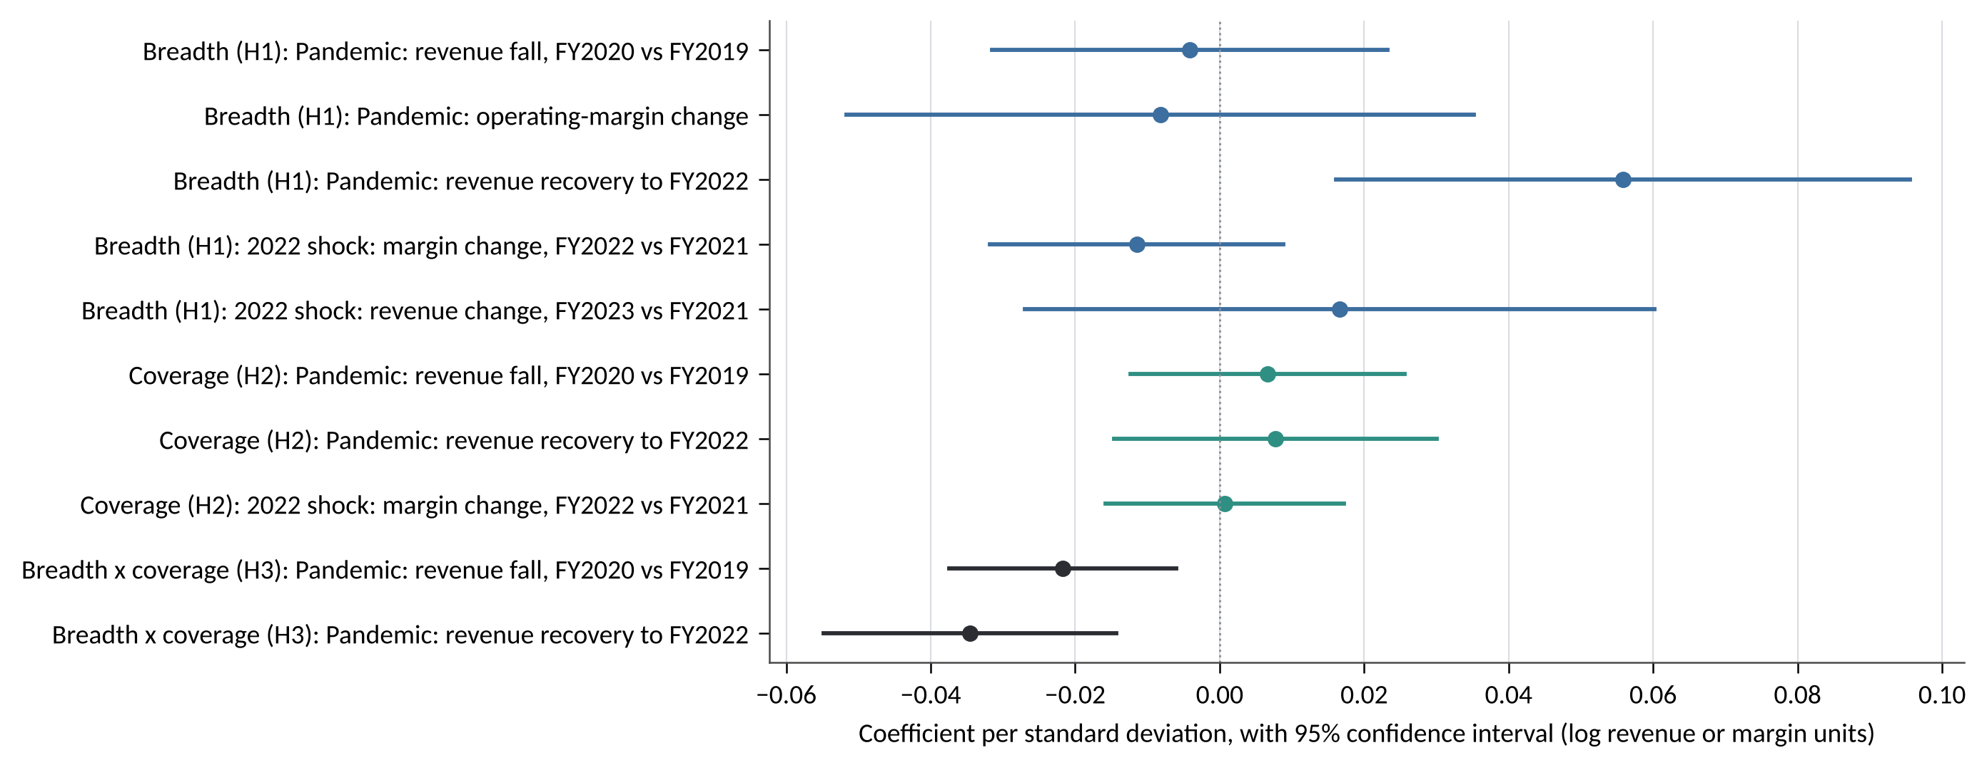
Note: Cross-sectional OLS with two-digit SIC and fiscal year-end month fixed effects, category intensities and controls; errors clustered by two-digit SIC. Source: author's analysis.
Two results run against the hypotheses. Breadth predicted stronger recovery: one standard deviation more pre-shock breadth went with 0.056 higher log revenue in fiscal 2022 relative to fiscal 2019 (p = 0.006, n = 627). The breadth by coverage interaction was negative for severity (b = −0.022, p = 0.007) and for recovery (b = −0.035, p < 0.001), the opposite of the sign H3 predicts. Marginal effects make the pattern concrete. Among firms reporting no documented action, breadth predicted recovery (b = 0.071, p < 0.001) and had no association with the fall (b = 0.005, p = 0.735). At the 90th percentile of coverage the recovery association disappeared (b = 0.007, p = 0.784) and breadth leaned towards a deeper fall (b = −0.035, p = 0.056). H3 is not supported.
Table 4 summarises the pre-specified robustness grid. The recovery association kept its sign in 22 of 23 checks and was significant at the five per cent level in 14; it weakened when the materiality threshold changed to one or five sentences and when diversity replaced breadth, so it depends on how convergence is counted. The negative interaction kept its sign in 23 of 23 checks and was significant in 16; it was weaker outside manufacturing. Results with the original dictionary were close to the main results (recovery b = 0.058, p = 0.006; severity b = −0.006, p = 0.735). In the firm fixed-effects panel, within-firm increases in breadth were not followed by significant changes in revenue growth (b = −0.018, p = 0.077, 4,464 firm-years), operating margin or the probability of an adverse year. Year-on-year updating of Item 1A rose from a mean of 0.025 in fiscal 2019 to 0.030 in fiscal 2020 and then fell back, but within-firm updating was not significantly associated with later revenue growth (b = 0.009, p = 0.071).
Table 4. Summary of the pre-specified robustness grid
Association | Primary b | Primary p | Same sign | p < 0.05, clustered | p < 0.05, HC1
Breadth on pandemic revenue fall | −0.004 | = 0.765 | 17 of 23 | 0 | 0
Breadth on pandemic recovery | 0.056 | = 0.006 | 22 of 23 | 14 | 11
Breadth x coverage on revenue fall | −0.022 | = 0.007 | 23 of 23 | 16 | 16
Breadth x coverage on recovery | −0.035 | < 0.001 | 21 of 23 | 17 | 17
Breadth on 2022 margin change | −0.011 | = 0.268 | 17 of 23 | 0 | 0
Breadth on FY2023 margin change | −0.095 | = 0.040 | 20 of 23 | 10 | 0
Note: Twenty-three checks per association: materiality thresholds of one and five sentences, diversity in place of breadth, no intensity controls, December year-end firms, Item 1A of at least 1,000 words, US-incorporated firms, base-year revenue of at least 100 million US dollars, manufacturing only and excluding manufacturing, reconfiguration, foreign income and updating controls, predictors filed before the shock, unwinsorised outcome and dropping each SIC division. Primary b for the breadth rows comes from the H1 model and for the interaction rows from the H3 model. Source: author's analysis.
The exposure-by-shock panel shows where losses did come from (Table 5). Firms with more macro-financial disclosure in fiscal 2018 had lower revenue growth in years of high policy uncertainty (b = −0.010, p = 0.009) and lower operating-margin change (b = −0.022, p = 0.028). Both associations held with industry-by-year fixed effects. Firms with more geopolitical disclosure had higher nominal revenue growth when geopolitical risk was high (b = 0.015, p < 0.001). So did firms with more supply-chain disclosure when supply pressure was high (b = 0.014, p < 0.001), with no margin effect in either case; the high-pressure years coincided with price inflation, so these firms passed costs into prices without widening margins. The term that captures compounding, breadth interacted with the number of indices in a high state, was close to zero for revenue (b = 0.002, p = 0.417) and margins (b = 0.000, p = 0.999). Exposure mattered channel by channel while combined exposure added nothing measurable.
Table 5. Pre-shock exposure and realised sensitivity to macro shocks, fiscal 2019 to 2025
Interaction | Revenue growth | Revenue growth | Margin change | Margin change
Geopolitical exposure x GPR | 0.0146** [0.0037] | 0.0094** [0.0035] | 0.0048 [0.0066] | 0.0050 [0.0058]
Supply-chain exposure x GSCPI | 0.0140** [0.0043] | 0.0178** [0.0057] | −0.0000 [0.0067] | 0.0082 [0.0115]
Trade exposure x trade policy uncertainty | 0.0024 [0.0026] | −0.0030 [0.0030] | 0.0017 [0.0041] | −0.0009 [0.0045]
Regulatory exposure x regulation uncertainty | 0.0003 [0.0026] | 0.0018 [0.0024] | 0.0051 [0.0037] | 0.0051 [0.0045]
Macro-financial exposure x EPU | −0.0098** [0.0037] | −0.0082* [0.0034] | −0.0217* [0.0098] | −0.0178* [0.0090]
Pandemic exposure x fiscal 2020 | −0.0188 [0.0114] | −0.0108 [0.0096] | −0.0190 [0.0141] | −0.0128 [0.0138]
Breadth x number of high indices | 0.0018 [0.0023] | 0.0004 [0.0023] | 0.0000 [0.0053] | 0.0012 [0.0063]
Firm-years | 4,567 | 4,567 | 4,300 | 4,300
Fixed effects | Firm, year | Firm, industry-year | Firm, year | Firm, industry-year
Note: Exposure is the fiscal 2018 category intensity, standardised; each index is the fiscal-year average, standardised. The number of high indices counts GPR, GSCPI, trade and regulation uncertainty and EPU more than one standard deviation above their mean plus fiscal 2020. Standard errors clustered by firm in brackets; * p < 0.05, ** p < 0.01. Source: author's analysis.
A final test asked whether the text measures help predict bad years. Models trained on outcome years up to fiscal 2022 were evaluated on fiscal 2023 to 2025 (1,770 firm-years, adverse-year rate 24.7 per cent). Adding the convergence, coverage, linkage and intensity measures to a baseline of size, leverage, cash, profitability and disclosure length raised the area under the ROC curve for adverse years from 0.558 to 0.588 and reduced out-of-sample explained variance in revenue growth from 0.035 to −0.021. Neither set of models predicts well and the disclosure measures add little.
Eight cases chosen by a rule fixed before any filing text was read show what the averages conceal (Table 7). Within each combination of breadth above or below the median and documented action present or absent, the rule takes the largest firm by fiscal 2019 revenue whose revenue fell by more than ten per cent and the largest whose revenue did not fall. Ford and Amazon each disclosed 5 material categories in fiscal 2018, including geopolitical and supply-chain risk. Neither reported a documented action. Ford's revenue fell by 18 per cent in fiscal 2020 while Amazon's rose by 38 per cent. Walmart and General Motors each disclosed 7 categories without documented action; Walmart's revenue rose by 7 per cent and General Motors' fell by 11 per cent. The pandemic reached vehicle makers and online retailers through opposite channels. Industry studies of the period document the same divergence (Ramelli and Wagner, 2020; Ding et al., 2021); the channel explains these outcomes far better than the number of risks each firm named. Among firms with documented actions the sentences classified as supply-chain actions were mostly acquisitions or logistics reorganisations: Marathon Petroleum's transfer of its refining logistics assets to MPLX, reported in its midstream segment, Caterpillar's acquisitions of ECM and Downer Freight Rail and UPS's earlier acquisition of Marken. Caterpillar's only macro-financial action was routine currency hedging. These are real actions, but they were not responses to the disclosed risks, which shows why documented coverage carries little information about preparedness.
Table 7. Illustrative cases from the pandemic episode
Firm | Breadth group; documented action | Material categories, FY2018 | Documented actions, FY2018 | Revenue change FY2019 to FY2020 | Revenue FY2022 vs FY2019
Ford Motor | at or below median; no | Geo, Trade, Cyber, Supply, Macro | None | −18.5% | 1.4%
Amazon.com | at or below median; no | Geo, Cyber, Supply, Climate, Macro | None | 37.6% | 83.3%
Marathon Petroleum | at or below median; yes | Geo, Reg, Cyber, Supply, Climate, Macro | Supply | −43.7% | 43.2%
United Parcel Service | at or below median; yes | Geo, Reg, Cyber, Climate, Macro | Supply | 14.2% | 35.4%
General Motors | above median; no | Geo, Trade, Reg, Cyber, Supply, Climate, Macro | None | −10.8% | 14.2%
Walmart | above median; no | Geo, Trade, Reg, Cyber, Supply, Climate, Macro | None | 6.7% | 16.6%
Caterpillar | above median; yes | Geo, Trade, Reg, Cyber, Supply, Climate, Macro | Supply, Macro | −22.4% | 10.4%
McKesson | above median; yes | Trade, Reg, Cyber, Supply, Climate, Macro, Pandemic | Supply | 3.1% | 19.7%
Note: Within each group the rule selects the largest firm by fiscal 2019 revenue whose revenue fell by more than ten per cent and the largest whose revenue did not fall. Material means at least three Item 1A sentences. Source: SEC EDGAR 10-K filings and XBRL company facts; author's analysis.

Discussion
The study set out to test whether disclosed risk convergence identifies fragile firms and whether documented response protects them. The answer to both is no, with one qualification about recovery. These findings sit uneasily with the polycrisis view at firm level (Lawrence et al., 2024; Renn et al., 2019). Systemic risk may well entangle at the level of economies, yet the number of risks a firm discloses does not show who will be hit hardest. Three explanations fit the evidence. The first is homogenisation. When most firms list most risks, breadth stops separating firms, in the same way that boilerplate weakens the information in risk factors more generally (Dyer et al., 2017; Hope et al., 2016; Cohen et al., 2020). Risk reporting responds to litigation and regulatory incentives as well as to exposure (Elshandidy et al., 2018; Campbell et al., 2014). Item 1A also kept lengthening after the 2020 amendments to Item 105 required headings and a summary for long risk sections (Securities and Exchange Commission, 2020). The second explanation is that disclosed exposure differs from realised sensitivity. The shock panel shows that sensitivity runs through specific channels, so a count of categories mixes channels that hurt, channels that are neutral and channels through which firms passed costs into prices. The third is that breadth partly records organisational scope. Firms with more varied operations disclose more categories and also have more ways to recover revenue once a shock passes, which fits the recovery result among firms with no documented action and the resilience literature on diversified resources (Ortiz-de-Mandojana and Bansal, 2016; DesJardine et al., 2019; Duchek, 2020).
The documented-response results speak to decoupling and to dynamic capabilities. Documented action in the business description and management discussion was rare, routine where it existed and concentrated in financial hedging and supply contracts. That pattern fits the view that risk documentation and risk management are loosely coupled (Power, 2009; Meyer and Rowan, 1977; Bromley and Powell, 2012). The negative interaction suggests a further point. Firms that disclosed broad exposure and also reported actions in fiscal 2018 were probably already responding to pressure that had arrived, such as the 2018 tariffs, so reported action marks exposure in progress more than prepared capacity. That reading is consistent with the attention-based view, in which action follows realised problems as often as foresight (Ocasio, 1997; Eggers and Kaplan, 2009; Nadkarni and Barr, 2008) and with crisis research showing that firms often begin to reconfigure after the shock rather than before it (Wenzel et al., 2021; Bundy et al., 2017; Mithani, 2020). It is an interpretation, because the design cannot separate reactive action from reverse causality.
The theoretical contribution is to separate three constructs that strategy research and practice tend to merge: disclosed exposure, documented response and realised sensitivity. Dynamic capabilities theory locates resilience in sensing, seizing and reconfiguring (Teece, 2007; Schilke et al., 2018). The evidence suggests that sensing as recorded in mandatory disclosure has become a near-universal ritual that no longer distinguishes firms, that seizing and reconfiguring leave a thin and routine trace in the same documents and that sensitivity to shocks is better read from exposure to particular channels than from the number of risks named. For strategic foresight research the implication is that weak-signal detection should be judged by what changes in the organisation, since year-on-year updating of risk disclosure peaked in the pandemic year without predicting later performance (Ansoff, 1975; Rohrbeck and Kum, 2018; Day and Schoemaker, 2016). For enterprise risk management the results support critiques that risk registers and aggregate scores add little decision value without evidence of exposure and action (Bromiley et al., 2015; Power, 2009; Andersen, 2008).

Implications for strategic leadership
The findings point to four practical changes, set out in Table 6 as a diagnostic that boards and executive teams can run on their own risk process. The first concerns the risk-factor list itself. A list that names all nine emerging risks, as 35.3 per cent of sampled firms did in fiscal 2025, tells a board little about relative exposure. The same is likely to hold for internal registers built from the same templates (Sheehan, 2020; Day and Dennis, 2022). Boards should ask management to rank risks by measured exposure, for example the share of revenue or cost passing through each channel. They should treat the published list as a compliance record.
The second change concerns transmission channels. Losses in the shock years ran through specific channels. Macro-financial exposure reduced growth and margins when policy uncertainty rose, while geopolitical and supply exposure coincided with higher nominal revenue as firms repriced. A board review should therefore trace each risk to the line of the income statement it would move and to the firm's ability to pass costs on, an approach close to the scenario discipline advocated in this journal (Schoemaker, 2022; Mortlock and Osiyevskyy, 2023; Calandro, 2020). The third change concerns response evidence. Few firms could point to completed actions on the risks they disclosed and the actions they reported were mostly routine hedges. Executive teams should keep a register of completed adaptive actions such as qualifying second suppliers, relocating capacity or changing contract terms. They should then review whether each material risk has one (Teece et al., 2016; Ivanov and Dolgui, 2020; Soleimani and Stauffer, 2026).
The fourth change concerns interaction. The evidence found no extra loss from combined exposure, so boards should not assume that more risks mean more fragility. They should instead look for the few explicit links that matter, such as a geopolitical event that would cut a single-source supply route, because linked reasoning made up about three per cent of risk text even in fiscal 2025. Scenario work that combines two or three named channels is more useful than a register that lists everything (Schoemaker and Day, 2021; Dencik et al., 2023; Welch, 2026). These recommendations follow from associations in public disclosure and accounting data and should be tested inside individual organisations before they are adopted as policy.
Table 6. A board diagnostic for converging strategic risks
Capability | What the evidence shows | Question for the board | Evidence to request
Anticipate | Risk lists grew to 7.83 of nine categories on average and stopped separating firms; updating peaked in fiscal 2020 | Which risks rose in our ranking this year and why? | Exposure ranked by revenue, cost or assets at stake, with the change from last year
Interpret | Only 3.1 per cent of risk sentences linked categories; combined exposure added no measurable loss | Which two or three links between risks would hurt us most? | Two-channel scenarios with named transmission paths and pass-through assumptions
Adapt | 71 per cent of firms reported no completed action on material risks in fiscal 2018; reported actions were mostly hedges | For each material risk, what have we changed in operations or contracts? | Register of completed adaptive actions with dates, owners and cost
Reinforce | Disclosure ratcheted up after shocks and rarely fell back; losses ran through specific channels | Which channels moved our income statement in the last shock? | Post-shock review of realised sensitivity by channel, fed into next year's ranking
Note: The diagnostic adapts the anticipate, interpret, adapt and reinforce sequence to the study's findings. Source: author's analysis.

Limitations and further research
Several limitations qualify the findings. The measures rest on disclosure text, which reflects legal incentives as well as exposure. The dictionary was also revised once after the first estimation following an audit carried out with an AI assistant; human double-coding of the released validation samples is required before the measures are treated as validated. Precision for supply-chain risk and for documented responses remained moderate while recall is incomplete, which biases associations towards zero. Outcomes are nominal accounting measures, so inflation in 2021 and 2022 affects revenue comparisons; share prices, real output and survival would test resilience in other ways (DesJardine et al., 2019; Ramelli and Wagner, 2020). The sample covers large US non-financial firms, so results may not hold for smaller firms, financial institutions or other disclosure regimes (Elshandidy et al., 2018). The episode models rely on two shocks and on industry clustering with about fifty clusters. The exposure-by-shock design identifies differential sensitivity under the assumption that fiscal 2018 exposure was not chosen in anticipation of later shocks (Borusyak et al., 2022). None of the estimates is causal. Further research could link disclosure to operational data on suppliers, facilities and contracts, use transformer models to separate generic from specific risk language and study whether boards that rank risks by measured exposure respond faster.

Conclusion
Between fiscal 2017 and 2025 US firms converged on disclosing almost every emerging strategic risk. That convergence did not identify the firms that lost most in the pandemic or the 2022 shocks, documented responses were too rare and routine to protect performance and losses ran through particular channels without measurable compounding. For strategy scholars the results separate disclosed exposure, documented action and realised sensitivity, three constructs that dynamic capabilities and risk management research often treat as one. For leaders the message is direct: a longer risk list is a compliance output while resilience depends on knowing which channels move the income statement and on completed actions against them.

Declarations
Data availability. All data come from public sources: SEC EDGAR filings and XBRL company facts and the published Geopolitical Risk, Economic Policy Uncertainty, World Uncertainty and Global Supply Chain Pressure indices. Collection scripts, retrieval manifests with checksums, the analysis plan with its dated deviations, derived datasets, validation samples and analysis code are available at https://github.com/Imomazin/research-projects (branch research/strategic-risk, folder Strategy and Strategic Management/Strategy and Leadership/Managing Emerging Strategic Risks; extracted filing text on branch data/strategic-risk).
Use of generative artificial intelligence. Claude (Anthropic) was used to write the data-collection and analysis code, to run the analyses, to draft the manuscript text and to code the sentence audit reported in Table A1. Every reported number is generated by versioned code from the archived data.

References
Ahir, H., Bloom, N. and Furceri, D. (2022), "The World Uncertainty Index", NBER Working Paper No. 29763, doi: 10.3386/w29763.
Andersen, T.J. (2008), "The Performance Relationship of Effective Risk Management: Exploring the Firm-Specific Investment Rationale", Long Range Planning, Vol. 41 No. 2, pp. 155-176, doi: 10.1016/j.lrp.2008.01.002.
Ansoff, H.I. (1975), "Managing Strategic Surprise by Response to Weak Signals", California Management Review, Vol. 18 No. 2, pp. 21-33, doi: 10.2307/41164635.
Baker, S.R., Bloom, N. and Davis, S.J. (2016), "Measuring Economic Policy Uncertainty", The Quarterly Journal of Economics, Vol. 131 No. 4, pp. 1593-1636, doi: 10.1093/qje/qjw024.
Baldwin, R. and Freeman, R. (2022), "Risks and Global Supply Chains: What We Know and What We Need to Know", Annual Review of Economics, Vol. 14 No. 1, pp. 153-180, doi: 10.1146/annurev-economics-051420-113737.
Bao, Y. and Datta, A. (2014), "Simultaneously Discovering and Quantifying Risk Types from Textual Risk Disclosures", Management Science, Vol. 60 No. 6, pp. 1371-1391, doi: 10.1287/mnsc.2014.1930.
Benigno, G., di Giovanni, J., Groen, J.J. and Noble, A.I. (2022), "The GSCPI: A New Barometer of Global Supply Chain Pressures", SSRN Electronic Journal, doi: 10.2139/ssrn.4114973.
Borusyak, K., Hull, P. and Jaravel, X. (2022), "Quasi-Experimental Shift-Share Research Designs", The Review of Economic Studies, Vol. 89 No. 1, pp. 181-213, doi: 10.1093/restud/rdab030.
Bourgeois, L.J. (1981), "On the Measurement of Organizational Slack", The Academy of Management Review, Vol. 6 No. 1, pp. 29-39, doi: 10.2307/257138.
Bromiley, P., McShane, M., Nair, A. and Rustambekov, E. (2015), "Enterprise Risk Management: Review, Critique, and Research Directions", Long Range Planning, Vol. 48 No. 4, pp. 265-276, doi: 10.1016/j.lrp.2014.07.005.
Bromley, P. and Powell, W.W. (2012), "From Smoke and Mirrors to Walking the Talk: Decoupling in the Contemporary World", Academy of Management Annals, Vol. 6 No. 1, pp. 483-530, doi: 10.5465/19416520.2012.684462.
Brown, S.V. and Tucker, J.W. (2011), "Large-Sample Evidence on Firms’ Year-over-Year MD&A Modifications", Journal of Accounting Research, Vol. 49 No. 2, pp. 309-346, doi: 10.1111/j.1475-679x.2010.00396.x.
Bundy, J., Pfarrer, M.D., Short, C.E. and Coombs, W.T. (2017), "Crises and Crisis Management: Integration, Interpretation, and Research Development", Journal of Management, Vol. 43 No. 6, pp. 1661-1692, doi: 10.1177/0149206316680030.
Calandro, J. (2020), "Risk as strategy: defending against catastrophic turns of fortune", Strategy & Leadership, Vol. 48 No. 4, pp. 29-35, doi: 10.1108/sl-04-2020-0061.
Caldara, D. and Iacoviello, M. (2022), "Measuring Geopolitical Risk", American Economic Review, Vol. 112 No. 4, pp. 1194-1225, doi: 10.1257/aer.20191823.
Cameron, A.C., Gelbach, J.B. and Miller, D.L. (2011), "Robust Inference With Multiway Clustering", Journal of Business & Economic Statistics, Vol. 29 No. 2, pp. 238-249, doi: 10.1198/jbes.2010.07136.
Campbell, J.L., Chen, H., Dhaliwal, D.S., Lu, H.M. and Steele, L.B. (2014), "The information content of mandatory risk factor disclosures in corporate filings", Review of Accounting Studies, Vol. 19 No. 1, pp. 396-455, doi: 10.1007/s11142-013-9258-3.
Carvalho, V.M., Nirei, M., Saito, Y.U. and Tahbaz-Salehi, A. (2021), "Supply Chain Disruptions: Evidence from the Great East Japan Earthquake", The Quarterly Journal of Economics, Vol. 136 No. 2, pp. 1255-1321, doi: 10.1093/qje/qjaa044.
Cho, T.S. and Hambrick, D.C. (2006), "Attention as the Mediator Between Top Management Team Characteristics and Strategic Change: The Case of Airline Deregulation", Organization Science, Vol. 17 No. 4, pp. 453-469, doi: 10.1287/orsc.1060.0192.
Cohen, L., Malloy, C. and Nguyen, Q. (2020), "Lazy Prices", The Journal of Finance, Vol. 75 No. 3, pp. 1371-1415, doi: 10.1111/jofi.12885.
Davis, S., Hansen, S. and Seminario-Amez, C. (2020), "Firm-Level Risk Exposures and Stock Returns in the Wake of COVID-19", NBER Working Paper No. 27867, doi: 10.3386/w27867.
Day, G.S. and Schoemaker, P.J.H. (2016), "Adapting to Fast-Changing Markets and Technologies", California Management Review, Vol. 58 No. 4, pp. 59-77, doi: 10.1525/cmr.2016.58.4.59.
Day, G.S. and Dennis, R. (2022), "Overcoming the preparedness paradox: five initiatives to ready businesses for an uncertain future disruption", Strategy & Leadership, Vol. 50 No. 5, pp. 9-14, doi: 10.1108/sl-05-2022-0051.
Dencik, J., Marshall, A. and Parham, G. (2023), "Building threat resilience into ecosystem strategy", Strategy & Leadership, Vol. 51 No. 4, pp. 37-41, doi: 10.1108/sl-04-2023-0049.
DesJardine, M., Bansal, P. and Yang, Y. (2019), "Bouncing Back: Building Resilience Through Social and Environmental Practices in the Context of the 2008 Global Financial Crisis", Journal of Management, Vol. 45 No. 4, pp. 1434-1460, doi: 10.1177/0149206317708854.
Ding, W., Levine, R., Lin, C. and Xie, W. (2021), "Corporate immunity to the COVID-19 pandemic", Journal of Financial Economics, Vol. 141 No. 2, pp. 802-830, doi: 10.1016/j.jfineco.2021.03.005.
Doz, Y.L. and Kosonen, M. (2010), "Embedding Strategic Agility", Long Range Planning, Vol. 43 No. 2-3, pp. 370-382, doi: 10.1016/j.lrp.2009.07.006.
Duchek, S. (2020), "Organizational resilience: a capability-based conceptualization", Business Research, Vol. 13 No. 1, pp. 215-246, doi: 10.1007/s40685-019-0085-7.
Dyer, T., Lang, M. and Stice-Lawrence, L. (2017), "The evolution of 10-K textual disclosure: Evidence from Latent Dirichlet Allocation", Journal of Accounting and Economics, Vol. 64 No. 2-3, pp. 221-245, doi: 10.1016/j.jacceco.2017.07.002.
Eggers, J.P. and Kaplan, S. (2009), "Cognition and Renewal: Comparing CEO and Organizational Effects on Incumbent Adaptation to Technical Change", Organization Science, Vol. 20 No. 2, pp. 461-477, doi: 10.1287/orsc.1080.0401.
Eisenhardt, K.M. and Martin, J.A. (2000), "Dynamic capabilities: what are they?", Strategic Management Journal, Vol. 21 No. 10-11, pp. 1105-1121, doi: 10.1002/1097-0266(200010/11)21:10/11<1105::aid-smj133>3.0.co;2-e.
Elliott, M., Golub, B. and Leduc, M.V. (2022), "Supply Network Formation and Fragility", American Economic Review, Vol. 112 No. 8, pp. 2701-2747, doi: 10.1257/aer.20210220.
Elshandidy, T., Shrives, P.J., Bamber, M. and Abraham, S. (2018), "Risk reporting: A review of the literature and implications for future research", Journal of Accounting Literature, Vol. 40 No. 1, pp. 54-82, doi: 10.1016/j.acclit.2017.12.001.
Fahlenbrach, R., Rageth, K. and Stulz, R.M. (2021), "How Valuable Is Financial Flexibility when Revenue Stops? Evidence from the COVID-19 Crisis", The Review of Financial Studies, Vol. 34 No. 11, pp. 5474-5521, doi: 10.1093/rfs/hhaa134.
Florackis, C., Louca, C., Michaely, R. and Weber, M. (2022), "Cybersecurity Risk", The Review of Financial Studies, Vol. 36 No. 1, pp. 351-407, doi: 10.1093/rfs/hhac024.
Gentzkow, M., Kelly, B. and Taddy, M. (2019), "Text as Data", Journal of Economic Literature, Vol. 57 No. 3, pp. 535-574, doi: 10.1257/jel.20181020.
Goldsmith-Pinkham, P., Sorkin, I. and Swift, H. (2020), "Bartik Instruments: What, When, Why, and How", American Economic Review, Vol. 110 No. 8, pp. 2586-2624, doi: 10.1257/aer.20181047.
Hassan, T.A., Hollander, S., van Lent, L. and Tahoun, A. (2019), "Firm-Level Political Risk: Measurement and Effects", The Quarterly Journal of Economics, Vol. 134 No. 4, pp. 2135-2202, doi: 10.1093/qje/qjz021.
Hassan, T.A., Hollander, S., van Lent, L., Schwedeler, M. and Tahoun, A. (2023), "Firm-Level Exposure to Epidemic Diseases: COVID-19, SARS, and H1N1", The Review of Financial Studies, Vol. 36 No. 12, pp. 4919-4964, doi: 10.1093/rfs/hhad044.
Helbing, D. (2013), "Globally networked risks and how to respond", Nature, Vol. 497 No. 7447, pp. 51-59, doi: 10.1038/nature12047.
Helfat, C.E. and Peteraf, M.A. (2015), "Managerial cognitive capabilities and the microfoundations of dynamic capabilities", Strategic Management Journal, Vol. 36 No. 6, pp. 831-850, doi: 10.1002/smj.2247.
Hendricks, K.B. and Singhal, V.R. (2005), "An Empirical Analysis of the Effect of Supply Chain Disruptions on Long-Run Stock Price Performance and Equity Risk of the Firm", Production and Operations Management, Vol. 14 No. 1, pp. 35-52, doi: 10.1111/j.1937-5956.2005.tb00008.x.
Hillmann, J. and Guenther, E. (2021), "Organizational Resilience: A Valuable Construct for Management Research?", International Journal of Management Reviews, Vol. 23 No. 1, pp. 7-44, doi: 10.1111/ijmr.12239.
Hope, O.K., Hu, D. and Lu, H. (2016), "The benefits of specific risk-factor disclosures", Review of Accounting Studies, Vol. 21 No. 4, pp. 1005-1045, doi: 10.1007/s11142-016-9371-1.
Hoyt, R.E. and Liebenberg, A.P. (2011), "The Value of Enterprise Risk Management", Journal of Risk and Insurance, Vol. 78 No. 4, pp. 795-822, doi: 10.1111/j.1539-6975.2011.01413.x.
Ivanov, D. and Dolgui, A. (2020), "Viability of intertwined supply networks: extending the supply chain resilience angles towards survivability. A position paper motivated by COVID-19 outbreak", International Journal of Production Research, Vol. 58 No. 10, pp. 2904-2915, doi: 10.1080/00207543.2020.1750727.
Kravet, T. and Muslu, V. (2013), "Textual risk disclosures and investors’ risk perceptions", Review of Accounting Studies, Vol. 18 No. 4, pp. 1088-1122, doi: 10.1007/s11142-013-9228-9.
Lang, M. and Stice-Lawrence, L. (2015), "Textual analysis and international financial reporting: Large sample evidence", Journal of Accounting and Economics, Vol. 60 No. 2-3, pp. 110-135, doi: 10.1016/j.jacceco.2015.09.002.
Lawrence, M., Homer-Dixon, T., Janzwood, S., Rockström, J., Renn, O. and Donges, J.F. (2024), "Global polycrisis: the causal mechanisms of crisis entanglement", Global Sustainability, Vol. 7, e6, doi: 10.1017/sus.2024.1.
Linnenluecke, M.K. (2017), "Resilience in Business and Management Research: A Review of Influential Publications and a Research Agenda", International Journal of Management Reviews, Vol. 19 No. 1, pp. 4-30, doi: 10.1111/ijmr.12076.
Loughran, T. and McDonald, B. (2011), "When Is a Liability Not a Liability? Textual Analysis, Dictionaries, and 10-Ks", The Journal of Finance, Vol. 66 No. 1, pp. 35-65, doi: 10.1111/j.1540-6261.2010.01625.x.
Loughran, T. and McDonald, B. (2016), "Textual Analysis in Accounting and Finance: A Survey", Journal of Accounting Research, Vol. 54 No. 4, pp. 1187-1230, doi: 10.1111/1475-679x.12123.
March, J.G. (1991), "Exploration and Exploitation in Organizational Learning", Organization Science, Vol. 2 No. 1, pp. 71-87, doi: 10.1287/orsc.2.1.71.
Marquis, C., Toffel, M.W. and Zhou, Y. (2016), "Scrutiny, Norms, and Selective Disclosure: A Global Study of Greenwashing", Organization Science, Vol. 27 No. 2, pp. 483-504, doi: 10.1287/orsc.2015.1039.
Meyer, J.W. and Rowan, B. (1977), "Institutionalized Organizations: Formal Structure as Myth and Ceremony", American Journal of Sociology, Vol. 83 No. 2, pp. 340-363, doi: 10.1086/226550.
Mithani, M.A. (2020), "Adaptation in the Face of the New Normal", Academy of Management Perspectives, Vol. 34 No. 4, pp. 508-530, doi: 10.5465/amp.2019.0054.
Mortlock, L. and Osiyevskyy, O. (2023), "Strategic scenario planning in practice: eight critical applications and associated benefits", Strategy & Leadership, Vol. 51 No. 6, pp. 22-29, doi: 10.1108/sl-08-2023-0090.
Nadkarni, S. and Barr, P.S. (2008), "Environmental context, managerial cognition, and strategic action: an integrated view", Strategic Management Journal, Vol. 29 No. 13, pp. 1395-1427, doi: 10.1002/smj.717.
Neunsinger, C., Reimann, L. and Fischer, T.M. (2026), "Capabilities-related disclosures and investors’ recognition of organisational resilience – an automated textual analysis of 10-K filings", European Accounting Review, Vol. 35 No. 4, pp. 999-1030, doi: 10.1080/09638180.2025.2606678.
Nocco, B.W. and Stulz, R.M. (2006), "Enterprise Risk Management: Theory and Practice", Journal of Applied Corporate Finance, Vol. 18 No. 4, pp. 8-20, doi: 10.1111/j.1745-6622.2006.00106.x.
O'Reilly, C.A. and Tushman, M.L. (2013), "Organizational Ambidexterity: Past, Present, and Future", Academy of Management Perspectives, Vol. 27 No. 4, pp. 324-338, doi: 10.5465/amp.2013.0025.
Ocasio, W. (1997), "Towards an Attention-based View of the Firm", Strategic Management Journal, Vol. 18 No. S1, pp. 187-206, doi: 10.1002/(sici)1097-0266(199707)18:1+<187::aid-smj936>3.0.co;2-k.
Ortiz-de-Mandojana, N. and Bansal, P. (2016), "The long-term benefits of organizational resilience through sustainable business practices", Strategic Management Journal, Vol. 37 No. 8, pp. 1615-1631, doi: 10.1002/smj.2410.
Petersen, M.A. (2009), "Estimating Standard Errors in Finance Panel Data Sets: Comparing Approaches", Review of Financial Studies, Vol. 22 No. 1, pp. 435-480, doi: 10.1093/rfs/hhn053.
Power, M. (2009), "The risk management of nothing", Accounting, Organizations and Society, Vol. 34 No. 6-7, pp. 849-855, doi: 10.1016/j.aos.2009.06.001.
Raisch, S. and Birkinshaw, J. (2008), "Organizational Ambidexterity: Antecedents, Outcomes, and Moderators", Journal of Management, Vol. 34 No. 3, pp. 375-409, doi: 10.1177/0149206308316058.
Ramelli, S. and Wagner, A.F. (2020), "Feverish Stock Price Reactions to COVID-19", The Review of Corporate Finance Studies, Vol. 9 No. 3, pp. 622-655, doi: 10.1093/rcfs/cfaa012.
Renn, O., Lucas, K., Haas, A. and Jaeger, C. (2019), "Things are different today: the challenge of global systemic risks", Journal of Risk Research, Vol. 22 No. 4, pp. 401-415, doi: 10.1080/13669877.2017.1409252.
Rindova, V. and Courtney, H. (2020), "To Shape or Adapt: Knowledge Problems, Epistemologies, and Strategic Postures under Knightian Uncertainty", Academy of Management Review, Vol. 45 No. 4, pp. 787-807, doi: 10.5465/amr.2018.0291.
Rohrbeck, R., Battistella, C. and Huizingh, E. (2015), "Corporate foresight: An emerging field with a rich tradition", Technological Forecasting and Social Change, Vol. 101, pp. 1-9, doi: 10.1016/j.techfore.2015.11.002.
Rohrbeck, R. and Kum, M.E. (2018), "Corporate foresight and its impact on firm performance: A longitudinal analysis", Technological Forecasting and Social Change, Vol. 129, pp. 105-116, doi: 10.1016/j.techfore.2017.12.013.
Sautner, Z., Van Lent, L., Vilkov, G. and Zhang, R. (2023), "Firm-Level Climate Change Exposure", The Journal of Finance, Vol. 78 No. 3, pp. 1449-1498, doi: 10.1111/jofi.13219.
Schilke, O., Hu, S. and Helfat, C.E. (2018), "Quo Vadis, Dynamic Capabilities? A Content-Analytic Review of the Current State of Knowledge and Recommendations for Future Research", Academy of Management Annals, Vol. 12 No. 1, pp. 390-439, doi: 10.5465/annals.2016.0014.
Schoemaker, P.J.H. and Day, G. (2021), "Preparing Organizations for Greater Turbulence", California Management Review, Vol. 63 No. 4, pp. 66-88, doi: 10.1177/00081256211022039.
Schoemaker, P.J.H. (2022), "How to prepare for ten process and content challenges of scenario planning", Strategy & Leadership, Vol. 50 No. 4, pp. 14-18, doi: 10.1108/sl-04-2022-0035.
Schoemaker, P.J.H. and Truumees, T.H. (2026), "Strategic leadership and agility in organizations", Strategy & Leadership, pp. 1-13, doi: 10.1108/sl-04-2026-0188.
Securities and Exchange Commission (2005), "Securities Offering Reform", Release Nos. 33-8591 and 34-52056, 70 FR 44721, issued 19 July 2005, effective 1 December 2005, available at: https://www.sec.gov/rule-release/33-8591.
Securities and Exchange Commission (2020), "Modernization of Regulation S-K Items 101, 103, and 105", Release No. 33-10825, adopted 26 August 2020, effective 9 November 2020, available at: https://www.sec.gov/corpfin/modernization-regulation-s-k-compliance-guide.
Sheehan, N.T. (2020), "Revisiting risk management in a time of crisis", Strategy & Leadership, Vol. 48 No. 6, pp. 35-43, doi: 10.1108/sl-09-2020-0115.
Soleimani, L. and Stauffer, R. (2026), "Navigating disruption: a practical framework for strategic response", Strategy & Leadership, pp. 1-18, doi: 10.1108/sl-01-2026-0031.
Teece, D.J., Pisano, G. and Shuen, A. (1997), "Dynamic capabilities and strategic management", Strategic Management Journal, Vol. 18 No. 7, pp. 509-533, doi: 10.1002/(sici)1097-0266(199708)18:7<509::aid-smj882>3.0.co;2-z.
Teece, D.J. (2007), "Explicating dynamic capabilities: the nature and microfoundations of (sustainable) enterprise performance", Strategic Management Journal, Vol. 28 No. 13, pp. 1319-1350, doi: 10.1002/smj.640.
Teece, D., Peteraf, M. and Leih, S. (2016), "Dynamic Capabilities and Organizational Agility: Risk, Uncertainty, and Strategy in the Innovation Economy", California Management Review, Vol. 58 No. 4, pp. 13-35, doi: 10.1525/cmr.2016.58.4.13.
Vecchiato, R. (2012), "Environmental uncertainty, foresight and strategic decision making: An integrated study", Technological Forecasting and Social Change, Vol. 79 No. 3, pp. 436-447, doi: 10.1016/j.techfore.2011.07.010.
Weick, K.E., Sutcliffe, K.M. and Obstfeld, D. (2005), "Organizing and the Process of Sensemaking", Organization Science, Vol. 16 No. 4, pp. 409-421, doi: 10.1287/orsc.1050.0133.
Welch, J. (2026), "The hidden risk of regulatory arbitrage: strategic exposure in global markets", Strategy & Leadership, pp. 1-19, doi: 10.1108/sl-04-2026-0182.
Wenzel, M., Stanske, S. and Lieberman, M.B. (2021), "Strategic responses to crisis", Strategic Management Journal, Vol. 42 No. 2, pp. O16-O27, doi: 10.1002/smj.3161.
Westphal, J.D. and Zajac, E.J. (2001), "Decoupling Policy from Practice: The Case of Stock Repurchase Programs", Administrative Science Quarterly, Vol. 46 No. 2, pp. 202-228, doi: 10.2307/2667086.
Williams, T.A., Gruber, D.A., Sutcliffe, K.M., Shepherd, D.A. and Zhao, E.Y. (2017), "Organizational Response to Adversity: Fusing Crisis Management and Resilience Research Streams", Academy of Management Annals, Vol. 11 No. 2, pp. 733-769, doi: 10.5465/annals.2015.0134.
Zscheischler, J., Westra, S., van den Hurk, B.J.J.M., Seneviratne, S.I., Ward, P.J., Pitman, A., AghaKouchak, A., Bresch, D.N., Leonard, M., Wahl, T. and Zhang, X. (2018), "Future climate risk from compound events", Nature Climate Change, Vol. 8 No. 6, pp. 469-477, doi: 10.1038/s41558-018-0156-3.

Appendix
Table A1. Audit of dictionary classifications
Category | Original dictionary: correct of audited | Revised dictionary, fresh sample: correct of audited
Geopolitical | 25 of 40 | 20 of 20
Trade policy | 40 of 40 | 20 of 20
Regulatory change | 40 of 40 | 16 of 20
Cybersecurity | 38 of 40 | 20 of 20
AI and technology | 33 of 40 | 20 of 20
Supply chain | 30 of 40 | 14 of 20
Climate and environment | 33 of 40 | 20 of 20
Macro-financial | 36 of 40 | 19 of 20
Pandemic | 36 of 40 | 20 of 20
Documented response | 65 of 120 | 36 of 60
Unclassified sentences with category content | 8 of 40 | 6 of 40
Pooled category precision | 0.86 | 0.94
Note: Sentences drawn by stratified random sampling with different seeds for the two audits and coded with an AI assistant against written category definitions. The coding sheets are released for human double-coding. For unclassified sentences the figure counts misses. Source: author's analysis.
Table A2. Correlations among pandemic-episode variables
Variable | 1 | 2 | 3 | 4 | 5 | 6 | 7 | 8 | 9 | 10
1 Severity
2 Recovery | 0.44
3 Breadth | −0.01 | 0.09
4 Coverage | −0.02 | −0.00 | −0.02
5 Linkage | −0.11 | −0.11 | 0.25 | 0.06
6 Updating | 0.01 | −0.03 | −0.15 | −0.08 | −0.04
7 Log assets | −0.19 | −0.17 | 0.15 | 0.03 | 0.26 | 0.03
8 Leverage | −0.10 | −0.18 | 0.07 | 0.06 | 0.09 | 0.04 | 0.31
9 Cash to assets | 0.29 | 0.13 | −0.07 | −0.07 | −0.22 | 0.00 | −0.39 | −0.10
10 Return on assets | −0.22 | −0.08 | 0.07 | 0.07 | 0.26 | 0.01 | 0.36 | −0.02 | −0.32
Note: Pearson correlations, pairwise complete observations, winsorised variables. Source: author's analysis.

